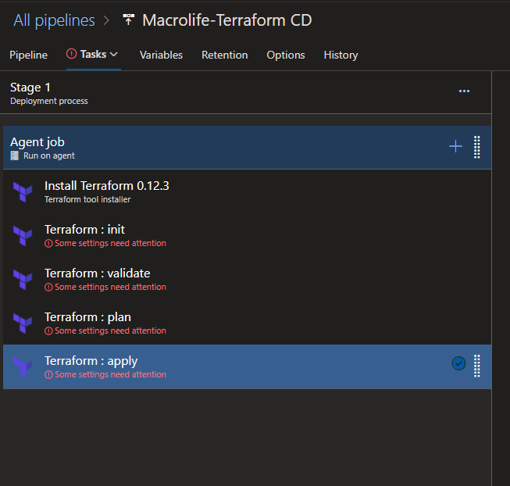

We can create a CD pipeline to automate infrastructure deployment using Terraform files.

We can provide all the required parameters and run terraform CLI commands via Terraform Tasks.

* Init
* Validate
* Plan
* Apply

To connect to Azure subscription we need to create a **service connection** with correct service principal